**Given the provided data, what are three conclusions that we can draw about crowdfunding campaigns?**

1. Based on the given data, we can see that the highest percentage of successful campaigns came from the technology category. Out of a total of 96 campaigns, they had a success rate of 66% and a failure rate of only 29%. Breaking this down even further, as you can see in figure 2, the subcategory of web, within technology had a success rate of 70% meanwhile only having a failure rate of only 23%
2. When looking at the overall data, out of the 1000 projects, theatre was responsible for 344 projects which puts them in the highest standing. Out of the 344 projects they were successful with 187. Out of the total successful projects, they are responsible for 33% of the successful projects which gives them the highest success rate.
3. Based on the given data, we can see that the highest percentage of failed campaigns came from the games category. Out of a total of 48 campaigns, they had a failure rate of 47.9% and a success rate of only 43.8%. Breaking this down even further using the data from figure 3, we can see that the subcategory of mobile games within, games had a failure rate of 61% and only a success rate of 31%.

**What are some limitations of this dataset?**

The dataset provided is not large enough to accurately represent all the categories and sub-categories. As a result, the results for some categories, such as the journalism category in Figure 1, may be inconclusive due to the small sample size. It is also possible that we do not have data for all categories and sub-categories in our set. Another limitation of this dataset is that we do not know the duration of the campaigns, which would provide valuable information about the length of time the campaigns ran and their success rate. For example, while all four journalism campaigns were successful, it would be helpful to know the interval at which they were run over a specific time frame.

**What are some other possible tables and/or graphs that we could create, and what additional value would they provide?**

Based on the data we have; I believe that adding a scatter plot showing the relationship between the number of failed campaigns and the number of successful campaigns for each sub-category could be valuable. This could help us identify any potential relationships between the number of failures and successes for each sub-category. Another table that would provide significant value would be one that excludes any significant outliers in our data. As a limitation of this dataset, it would also be helpful to create a graph showing the timeline of how long the campaigns were run for. This could provide valuable information about the length of time the campaigns ran and their success rate.

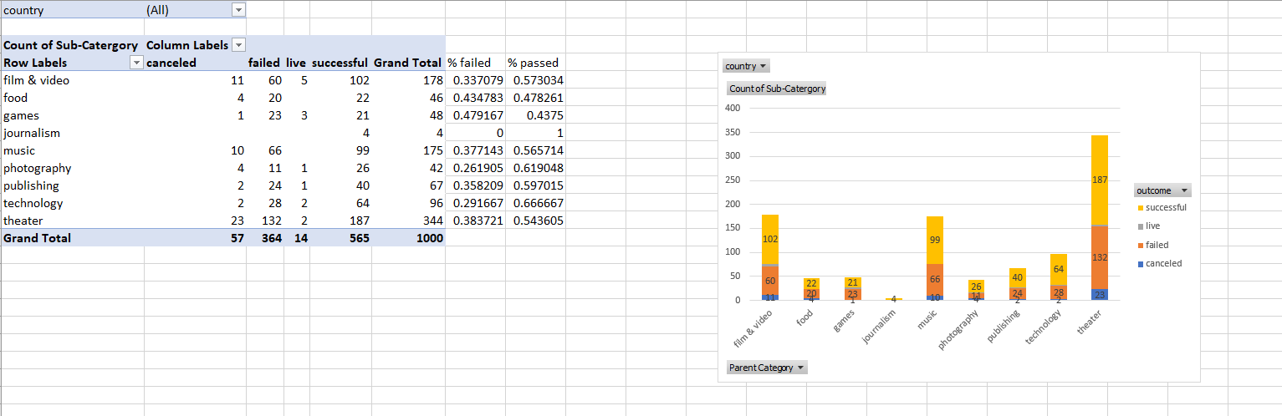

Figure

Figure 3

Figure